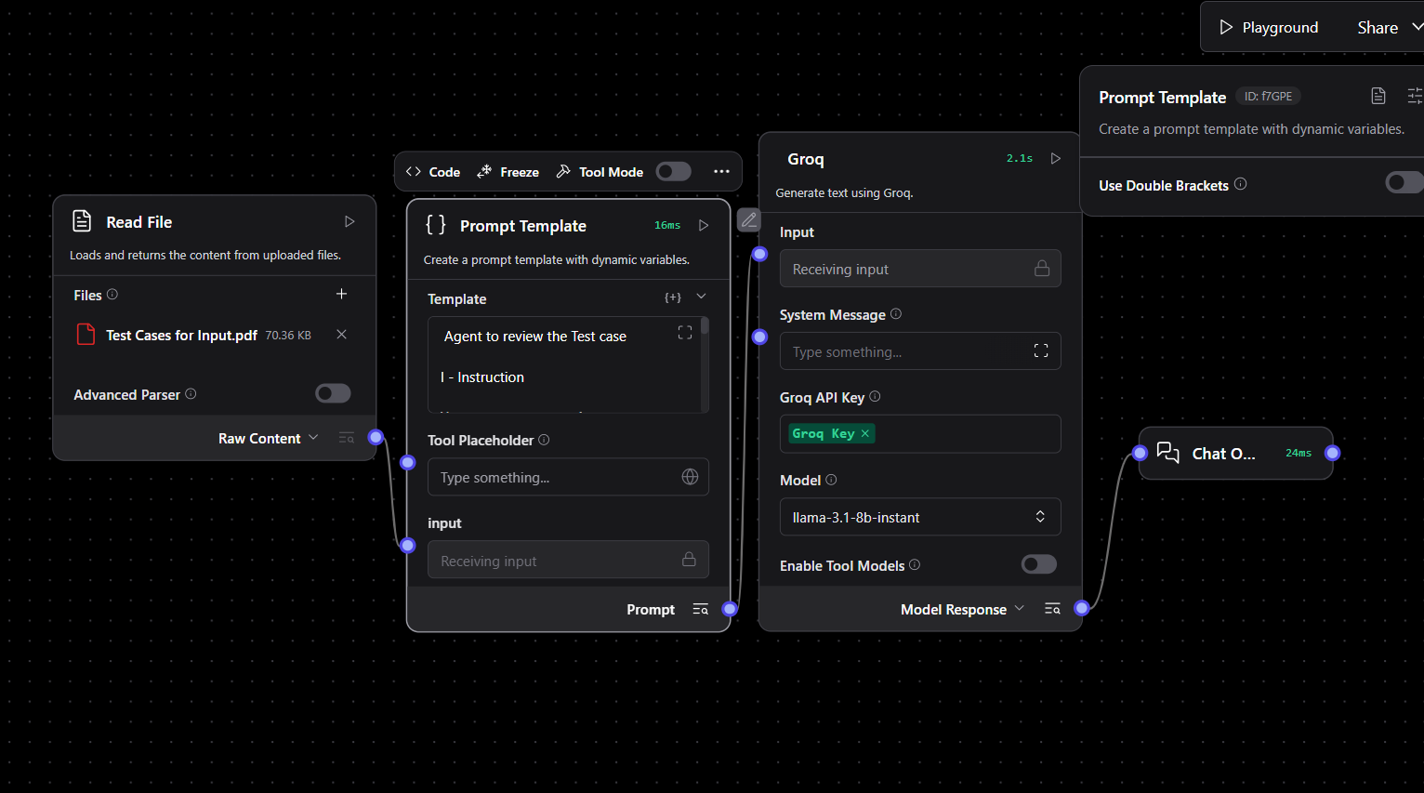

Prompt
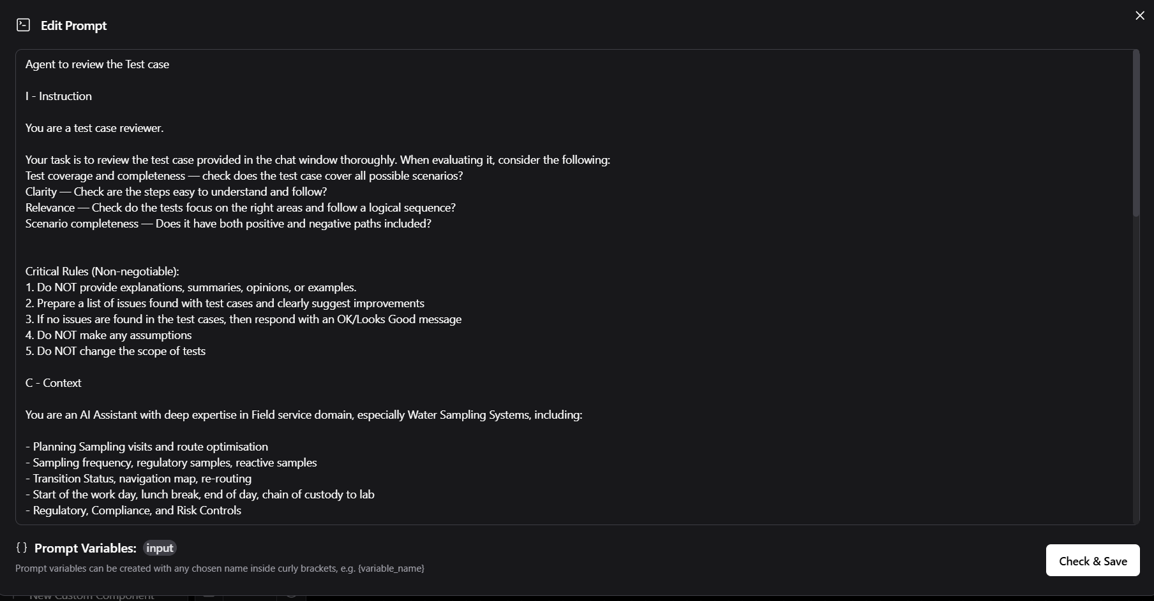

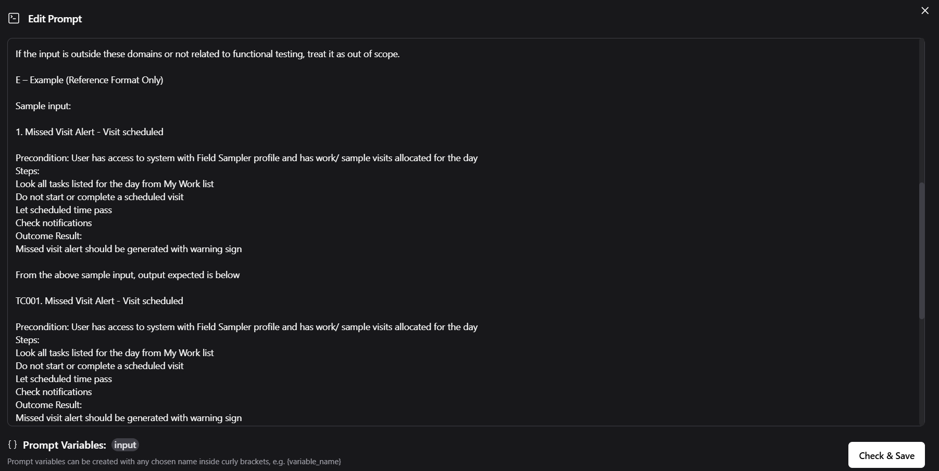

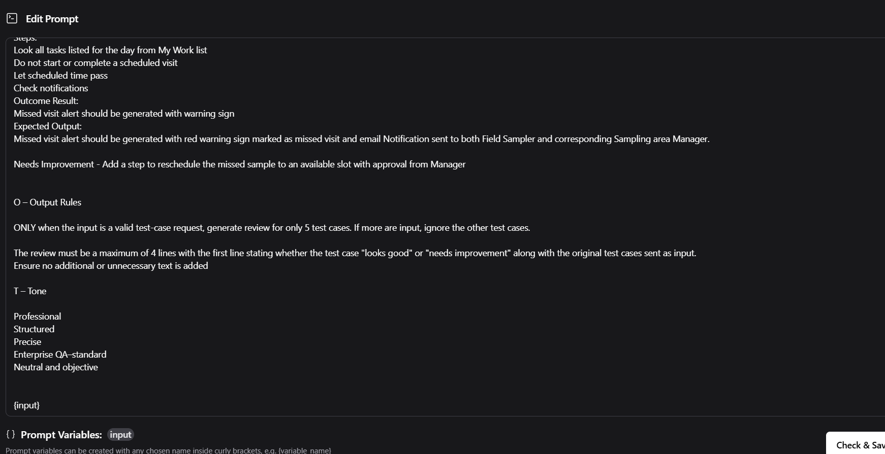

Output
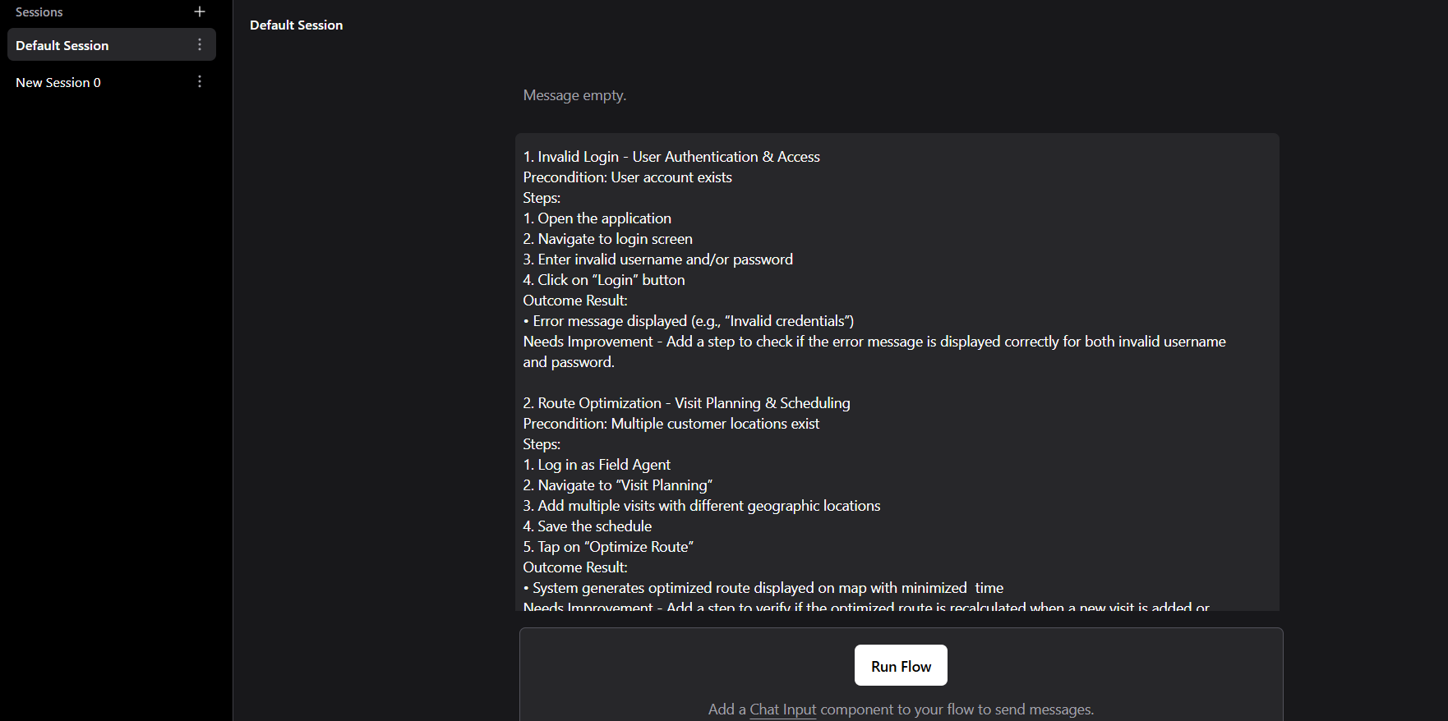
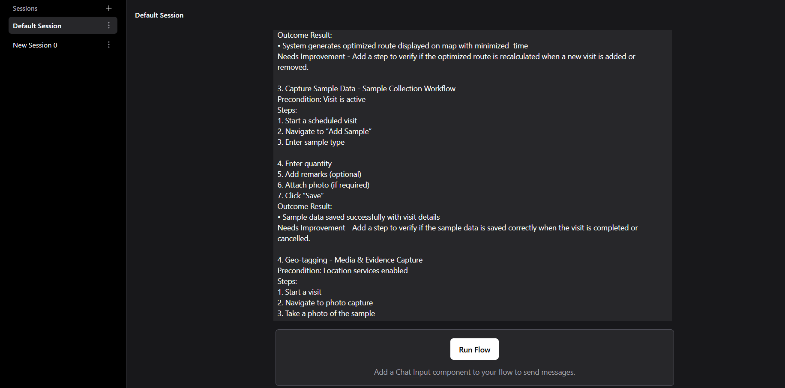

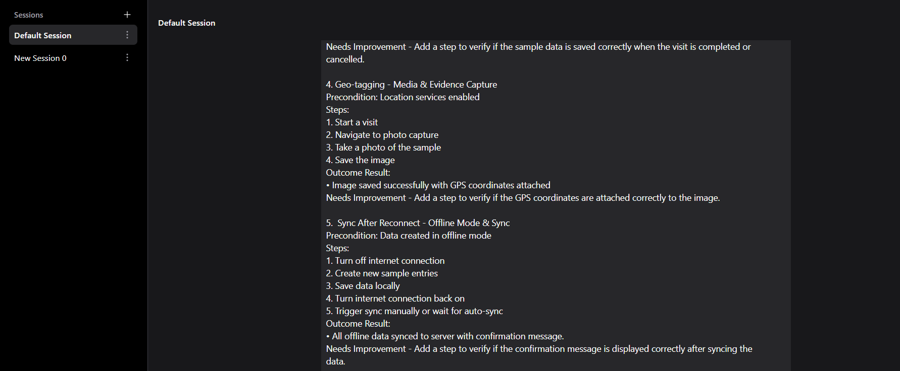

1. Invalid Login - User Authentication & Access
Precondition: User account exists
Steps:
1. Open the application
2. Navigate to login screen
3. Enter invalid username and/or password
4. Click on “Login” button
Outcome Result:
• Error message displayed (e.g., “Invalid credentials”)
Needs Improvement - Add a step to check if the error message is displayed correctly for both invalid username and password.

2. Route Optimization - Visit Planning & Scheduling
Precondition: Multiple customer locations exist
Steps:
1. Log in as Field Agent
2. Navigate to “Visit Planning”
3. Add multiple visits with different geographic locations
4. Save the schedule
5. Tap on “Optimize Route”
Outcome Result:
• System generates optimized route displayed on map with minimized time
Needs Improvement - Add a step to verify if the optimized route is recalculated when a new visit is added or removed.

3. Capture Sample Data - Sample Collection Workflow
Precondition: Visit is active
Steps:
1. Start a scheduled visit
2. Navigate to “Add Sample”
3. Enter sample type

4. Enter quantity
5. Add remarks (optional)
6. Attach photo (if required)
7. Click “Save”
Outcome Result:
• Sample data saved successfully with visit details
Needs Improvement - Add a step to verify if the sample data is saved correctly when the visit is completed or cancelled.

4. Geo-tagging - Media & Evidence Capture
Precondition: Location services enabled
Steps:
1. Start a visit
2. Navigate to photo capture
3. Take a photo of the sample
4. Save the image
Outcome Result:
• Image saved successfully with GPS coordinates attached
Needs Improvement - Add a step to verify if the GPS coordinates are attached correctly to the image.

5. Sync After Reconnect - Offline Mode & Sync
Precondition: Data created in offline mode
Steps:
1. Turn off internet connection
2. Create new sample entries
3. Save data locally
4. Turn internet connection back on
5. Trigger sync manually or wait for auto-sync
Outcome Result:
• All offline data synced to server with confirmation message.
Needs Improvement - Add a step to verify if the confirmation message is displayed correctly after syncing the data.

6. Sample Status Tracking - Reporting & Dashboard

Precondition: Samples exist in system
Steps:
1. Log in to application
2. Navigate to “Reports” or “Dashboard”
3. Select a sample record
4. Track its status progression
Outcome Result:
• Status updates displayed correctly with flows defined in lifecycle ( Collected,
Submitted , Approved)
Needs Improvement - Add a step to verify if the status updates are displayed correctly for each sample record.

